CWMP Data Models for Printers and MFDs
(CWMPMFD)

Status: White Paper

Abstract: The purpose of this white paper is to propose input for future Broadband Forum Technical Reports that would define new data models for printers, multifunction devices (MFDs), and other imaging devices that are managed as customer premises equipment (CPE) devices:

(a) Guidance for remote management of printers and MFDs via Broadband Forum CPE WAN Management Protocol (CWMP) [TR-069];
(b) Guidance for CWMP Proxy implementations that communicate with printers and MFDs using their native IPP, SNMP, and/or web services, e.g., PWG Print Service;
(c) Data model for PrintService, with an XML schema binding, that follows the BBF Data Model Template for TR-069-Enabled-Devices [TR-106] and is composed of the machine-translated existing objects, element groups, and elements defined in the PWG Semantic Model v2.0 XML schema; and

(d) Data models for Scan, Fax, MFD (i.e., System) and various other PWG SM services, that follow the BBF Data Model Template for TR-069-Enabled-Devices [TR-106] and are each composed of the machine-translated existing objects, element groups, and elements defined in the PWG Semantic Model v2.0 XML schema.

This document is a PWG White Paper. For a definition of a "PWG White Paper", see:
ftp://ftp.pwg.org/pub/pwg/general/pwg-process30.pdf

This document is available electronically at:
ftp://ftp.pwg.org/pub/pwg/BOFs/cwmp/white-cwmpmfdmodel10-20120312.pdf
Copyright © 2012 The Printer Working Group. All rights reserved.
This document may be copied and furnished to others, and derivative works that comment on, or otherwise explain it or assist in its implementation may be prepared, copied, published and distributed, in whole or in part, without restriction of any kind, provided that the above copyright notice, this paragraph and the title of the Document as referenced below are included on all such copies and derivative works. However, this document itself may not be modified in any way, such as by removing the copyright notice or references to the IEEE-ISTO and the Printer Working Group, a program of the IEEE-ISTO.
Title: Broadband Forum CWMP Multifunction Device Data Model (CWMPMFD)
The IEEE-ISTO and the Printer Working Group DISCLAIM ANY AND ALL WARRANTIES, WHETHER EXPRESS OR IMPLIED INCLUDING (WITHOUT LIMITATION) ANY IMPLIED WARRANTIES OF MERCHANTABILITY OR FITNESS FOR A PARTICULAR PURPOSE.
The Printer Working Group, a program of the IEEE-ISTO, reserves the right to make changes to the document without further notice. The document may be updated, replaced or made obsolete by other documents at any time.
The IEEE-ISTO takes no position regarding the validity or scope of any intellectual property or other rights that might be claimed to pertain to the implementation or use of the technology described in this document or the extent to which any license under such rights might or might not be available; neither does it represent that it has made any effort to identify any such rights.
The IEEE-ISTO invites any interested party to bring to its attention any copyrights, patents, or patent applications, or other proprietary rights which may cover technology that may be required to implement the contents of this document. The IEEE-ISTO and its programs shall not be responsible for identifying patents for which a license may be required by a document and/or IEEE-ISTO Industry Group Standard or for conducting inquiries into the legal validity or scope of those patents that are brought to its attention. Inquiries may be submitted to the IEEE-ISTO by e-mail at: ieee-isto@ieee.org.
The Printer Working Group acknowledges that the IEEE-ISTO (acting itself or through its designees) is, and shall at all times, be the sole entity that may authorize the use of certification marks, trademarks, or other special designations to indicate compliance with these materials.
Use of this document is wholly voluntary. The existence of this document does not imply that there are no other ways to produce, test, measure, purchase, market, or provide other goods and services related to its scope.

About the IEEE-ISTO
The IEEE-ISTO is a not-for-profit corporation offering industry groups an innovative and flexible operational forum and support services. The IEEE-ISTO provides a forum not only to develop standards, but also to facilitate activities that support the implementation and acceptance of standards in the marketplace. The organization is affiliated with the IEEE (http://www.ieee.org/) and the IEEE Standards Association (http://standards.ieee.org/).
For additional information regarding the IEEE-ISTO and its industry programs visit:
http://www.ieee-isto.org
About the IEEE-ISTO PWG
The Printer Working Group (or PWG) is a Program of the IEEE Industry Standards and Technology Organization (ISTO) with member organizations including printer manufacturers, print server developers, operating system providers, network operating systems providers, network connectivity vendors, and print management application developers. The group is chartered to make printers and the applications and operating systems supporting them work together better. All references to the PWG in this document implicitly mean “The Printer Working Group, a Program of the IEEE ISTO.” In order to meet this objective, the PWG will document the results of their work as open standards that define print related protocols, interfaces, procedures and conventions. Printer manufacturers and vendors of printer related software will benefit from the interoperability provided by voluntary conformance to these standards.
In general, a PWG standard is a specification that is stable, well understood, and is technically competent, has multiple, independent and interoperable implementations with substantial operational experience, and enjoys significant public support.
For additional information regarding the Printer Working Group visit:
http://www.pwg.org
Contact information:
The Printer Working Group
c/o The IEEE Industry Standards and Technology Organization
445 Hoes Lane
Piscataway, NJ 08854
USA

Table of Contents
1. Introduction 6
2. Terminology 8
2.1 Conformance Terminology 8
2.2 Printing Terminology 8
2.3 Telecommunications Terminology 8
3. Requirements 11
3.1 Rationale for Printer and MFD Management via CWMP 11
3.1.1 Rationale from IETF and PWG Perspective 11
3.1.2 Rationale from Broadband Forum Perspective 12
3.2 Use Cases 14
3.2.1 MFDs managed by Telecom Providers 14
3.2.2 MFDs managed by MPS Providers 14
3.2.3 MFDs managed by Enterprise IT Staff 14
3.2.4 Print Kiosks managed by Telecom Providers 15
3.3 Deployment Scenarios 16
3.4 Out of Scope 16
3.5 Design Requirements 16
4. CWMP Data Models 18
4.1 Technical Approach 18
4.1.1 XML Format of BBF CWMP and PWG SM Models 18
4.1.2 Translation of PWG SM into CWMP Data Models 18
4.1.3 Simple Parameter Datatypes 19
4.1.4 Short Parameter Qualified Names 19
4.2 PWG SM PrintService Model 20
4.3 CWMP PrintService Data Model 29
5. Proxy Implementation Guidance 36
5.1 PWG PrintService to IPP Proxy Guidance 36
5.2 PWG PrintService to SNMP Proxy Guidance 41
6. Conformance Requirements 41
7. Internationalization Considerations 42
8. Security Considerations 42
9. IANA Considerations 42
10. References 43
10.1 Normative References 43
10.2 Informative References 44
11. Editors' Addresses 45
12. Change History 46
12.1 March 12, 2012 46
12.2 December 5, 2011 46
12.3 December 3, 2011 46
12.4 September 26, 2011 46
12.5 September 21, 2011 47
12.6 September 14, 2011 47

List of Figures
Figure 1 – Broadband Forum CWMP End-to-End Architecture 12
Figure 2 – Print Kiosks and Secure Cloud Print Service 15
Figure 3 – PWG SM System Object 20
Figure 4 – PWG SM PrintService Object 21
Figure 5 – PWG SM PrintServiceCapabilities Group 21
Figure 6 – PWG SM PrintServiceConfiguration Group (subunits) 22
Figure 7 – PWG SM PrintServiceDefaults Group 22
Figure 8 – PWG SM PrintServiceDescription Group (excerpt) 23
Figure 9 – PWG SM PrintServiceStatus Group 24
Figure 10 – PWG SM Print JobTable Group (w/ history) 25
Figure 11 – PWG SM InputTray Object 26
Figure 12 – PWG SM Console Object 27
Figure 13 – PWG SM Marker Object 28
Figure 14 – PWG SM MarkerSupply Object 29

List of Tables
Table 1 – PWG PrintService to IPP Proxy Mapping 36

- Introduction
This document focuses on the evolution of the Managed Print Services (MPS) industry and the broadband Telecommunications (Telecom) industry and has primary goals of supporting automatic, remote, secure configuration of newly installed printers and then securely managing them throughout their lifecycle.
Since the mid-1990s, high-quality digital printing technologies have become widespread. This has led to the convergence of traditional copiers and printers and the subsequent development of a new class of multifunction devices (MFDs). Older stand-alone office equipment typically performed a single copy, print, scan, or fax function. Newer MFDs have evolved to support all of these basic functions and also often include email, resource management, document transform, document storage, and other imaging services.
In recent years, managed print service (MPS) providers have offered proactive supplies and maintenance service contracts to business, government, and university customers. The key limitation for MPS market growth has been the lack of a single, comprehensive monitoring and management interface across the current generation of MFDs.
Currently, device and service information about printers is typically available via SNMP using IETF MIB-II [RFC1213], IETF Host Resources MIB v2 [RFC2790], PWG Imaging System State and Counter MIB v2 [PWG5106.3], PWG Job Monitoring MIB [RFC2707], IETF Printer MIB v2 [RFC3805], IETF Finisher MIB [RFC3806], PWG Printer Port Monitor MIB [PWG5107.1], and PWG Imaging System Power MIB [PWG5106.3].
On the other hand, service and job information about printers is typically available via IPP/1.1 [RFC2911] and often via the newer IPP versions 2.0, 2.1, and 2.2 [PWG5100.12].
Currently information about other imaging services and MFDs overall is not available via open standard interfaces (i.e., the suite of PWG Semantic Model abstract services and WSDL/SOAP bindings).
Meanwhile, the Telecommunications (hereafter, Telecom) service providers have also changed dramatically. High-speed Internet and other data communications customer endpoints have become widespread, affordable, and reliable. Older single-function telecom customer premise equipment [CPE] such as land line telephones, set-top boxes (STBs), and mobile phones have converged and given rise to multifunction high-speed media offerings.
In the past, telecom infrastructure devices such as routers, bridges, cable modems, and DSL modems were monitored and managed via SNMP and TELNET/SSH. More recently, the telecom industry has migrated to the use of Broadband Forum CPE WAN Management Protocol (CWMP) [TR-069]. And the current generation of CPE devices are typically also managed using CWMP.
Telecom providers have now joined MPS providers as suppliers of printers and MFDs under service contracts in homes and businesses. Note that current telecom CPE device have more complex life-cycles than current printers and MFDs. A telecom CPE device is typically installed with entirely automatic initial configuration and is subsequently frequently updated with new firmware and new services, again via automatic configuration.
- Terminology
  - Conformance Terminology
Capitalized terms, such as MUST, MUST NOT, REQUIRED, SHOULD, SHOULD NOT, MAY, and OPTIONAL, have special meaning relating to conformance as defined in RFC 2119 [RFC2119].
  - Printing Terminology
Normative definitions and semantics of printing terms are imported from IETF Printer MIB v2 [RFC3805], IETF Finisher MIB [RFC3806], and IETF IPP/1.1 [RFC2911].
This document also defines the following protocol roles in order to specify unambiguous conformance requirements:
IPP Client - Initiator of outgoing IPP session requests and sender of outgoing IPP operation requests (HTTP/1.0 Client [RFC1957] / HTTP/1.1 Client [RFC2616]).
IPP Printer - Listener for incoming IPP session requests and receiver of incoming IPP operation requests (HTTP/1.0 Server [RFC1957] / HTTP/1.1 Server [RFC2616]).
SNMP MIB Agent: Listener for incoming SNMP Get and Set management requests and sender of optional outgoing SNMP notifications for a Printer or MFD (i.e., an SNMP Agent).
SNMP MIB Client: Initiator of outgoing SNMP Get and Set management requests and receiver of optional incoming SNMP notifications for a Printer or MFD (i.e., an SNMP Manager).
  - Telecommunications Terminology
Normative definitions and semantics of telecommunications management terms are imported from Broadband Forum CPE WAN Management Protocol [TR-069], including the following:

Applied – A change to the Customer Premise Equipment (CPE) configuration has been applied when the CPE has stopped using the previous configuration and begun using the new Subunits.
Auto-Configuration Server (ACS) – This is a component in the broadband network responsible for auto-configuration of the Customer Premise Equipment (CPE) for advanced services.
Committed – A change to the Customer Premise Equipment (CPE) configuration has been committed when the change has been fully validated, the new configuration appears in the configuration data model for subsequent Auto-Configuration Server (ACS) operations to act on, and the change will definitely be applied in the future, as required by the protocol specification.
Customer Premises Equipment (CPE) – Refers to any TR-069-compliant device and therefore covers both Internet Gateway Devices (IGDs) and LAN-side end devices.
Data Model – A hierarchical set of parameters that define the managed objects accessible via [TR-069] for a particular device or service.
Deployment Unit (DU) – An entity that can be individually deployed on the Execution Environment. A Deployment Unit can consist of functional Execution Units and/or configuration files and/or other resources.
Device – Used interchangeably with CPE in [TR-069].
Execution Environment (EE) – A software platform that enables the dynamic loading and unloading of Software Modules. Typical examples include Linux, OSGi, .NET, and Java ME. Some Execution Environments enable the sharing of resources amongst modules.
Execution Unit (EU) – A functional entity that, once started, initiates processes to perform tasks or provide services, until it is stopped. Execution Units are deployed by Deployment Units. The following list of concepts could be considered Execution Units: services, scripts, software components, libraries, etc.
Internet Gateway Device (IGD) – A Customer Premise Equipment (CPE) device, typically a broadband router, that acts as a gateway between the WAN and the LAN.
Managed Print Service (MPS) – A service model that adds value to MFDs and printers by combining provisioning, maintenance, and supplies into Service Level Agreements (SLAs).
Parameter – A name-value pair representing a manageable CPE parameter made accessible to an ACS for reading and/or writing.
Residential Gateway (RGW) – A gateway between the end user premise and the broadband service network (i.e., the Telecom network, not the Internet) that is introduced for architectural clarity in [TR-196].
Set Top Box (STB) – A television set top box that supports multimedia and Internet access by the end user.
Session – A contiguous sequence of CWMP transactions between a Customer Premise Equipment (CPE) and an Auto-Configuration Server (ACS). Note that a Session may span multiple TCP connections.
Software Module – The common term for all software (except firmware) that will be installed on an Execution Environment, including the concepts of Deployment Units and Execution Units.
Transaction – A message exchange between a Customer Premise Equipment (CPE) and an Auto-Configuration Server (ACS) consisting of a single request followed by a single response, initiated either by the CPE or ACS.
- Requirements
  - Rationale for Printer and MFD Management via CWMP
    - Rationale from IETF and PWG Perspective
IETF and PWG standards for the printing industry define:
A rationale for an abstract model of printing (to support alternate encodings and protocols) in section 3 of the IETF IPP Rationale [RFC2568];
A set of design goals for status monitoring in a printing protocol in section 3.1.3 'Viewing the status and capabilities of a printer' (for End User), section 3.2.1 'Alerting' (for Operator), and section 3.3 'Administrator' (the bullet requirement to 'administrate billing or other charge-back mechanisms') of the IETF IPP Design Goals [RFC2567];
An abstract model of a Print Service (i.e., ISO DPA Logical Printer) and a Print Device (i.e., ISO DPA Physical Printer) in section 2.1 of IETF IPP/1.1 [RFC2911];
An abstract model of a Print Device and contained Subunits in section 2.2 of the IETF Printer MIB v2 [RFC3805];
An abstract model of Finishing Subunits integrated into the Printer Model (from [RFC3805]) in section 3 of the IETF Finisher MIB [RFC3806];
A set of Finishing Subunit types in the 'FinDeviceTypeTC' textual convention in IANA Finisher MIB [IANAFIN], originally published in section 7 of the IETF Finisher MIB [RFC3806]; and
An abstract model of a Multifunction Device in section 2 of the PWG MFD Model and Common Semantics [PWG5108.01].
When deploying printers and MFDs in home and office CPE environments based on telecom service agreements, initial configuration via SNMP and Embedded Web Server is neither feasible nor scalable.
Therefore CWMP printer and MFD data models SHOULD:
Standardize native CWMP support for secure operations on printers and MFDs;
Standardize capabilities to manage, provision, and service these CWMP-based printers and MFDs;
Encourage adoption of modern IPP-based printing infrastructures;
Encourage adoption of modern PWG Semantic Model-based MFD infrastructures.
    - Rationale from Broadband Forum Perspective
The Broadband Forum CPE WAN Management Protocol (CWMP) standard [TR-069] defines a set of standard interfaces between the Auto-Configuration Server (ACS) of a service provider and all customer premise equipment (CPE) devices in a customer's network that supports the CWMP device data model.
Figure 1 below is excerpted from section 1.2 of Broadband Forum CWMP [TR-069] and depicts the scope of CWMP in an end-to-end WAN network architecture.

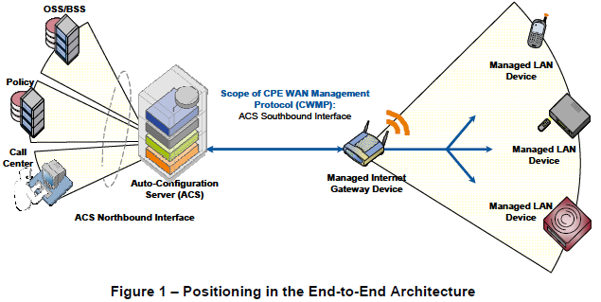
Figure 1 – Broadband Forum CWMP End-to-End Architecture
Implementation of CWMP in MFDs would enable a service provider to offer the following advantages throughout the lifecycle of an MFD product:
Ease of Deployment: Web-based remote selection, activation, and control of pay-per-use services (e.g. print, copy, scan, fax);
Touchless Installation: Automatic discovery, secure configuration, and policy-based setup of MFDs, printers, and their imaging services that is scalable to support many thousands of users according to each user’s/group's profile and service contract and the customer's business policies (e.g., access control and monetization of print, fax, scan, copy and other services based on time, volume, user ID, features, payment models, etc.). This is similar to the way mobile phones can be remotely identified, configured, and setup on a broadband network today;
Remote Device Management: Provides automatic and secure software/firmware downloads, upgrades, patches, and new value-add services to MFDs, printers, and other imaging devices – provides automatic performance/status monitoring of imaging devices and services; and
Remote Diagnostics/Troubleshooting: Provides improved problem resolution capability – eliminates unnecessary and costly device replacement – enhances customer support process.
Broadband Forum CWMP standards for the Telecom industry include:
A broadband management architecture for CPE devices in CWMP [TR-069];
A data model template for all devices that support CWMP in [TR106];
A common device data model in [TR-181];
An Internet Gateway Device (IGD) data model in [TR-098]; and
A series of device-specific CWMP data models based on [TR-106] for DSLHomeTM for VoIP [TR-104], Set Top Boxes [TR-135], Storage Service enabled devices [TR-140], and Femto access points [TR-196].
There is no currently defined standard TR-069 data model defined for MFDs.
By collaborating to propose this MFD data model, the PWG is leading the way for the inclusion of MFDs and printers as part of the managed services offered by Telecom operators by leveraging the PWG Semantic Model [PWG5108.1]. In addition, the PWG is supporting the use of CWMP for MFDs and printers by MPS providers, who will also gain the advantage of managing any TR-069 enabled device – be it a storage device, communications device, or a computing device – this CWMP support would allow MPS providers to evolve into Managed Service Providers (MSPs), in order to compete more effectively with traditional IT and Telecom service providers.
  - Use Cases
The use cases below are written from the perspective of the End User or local Admin of the MFD or printer being managed as a CPE device.
    - MFDs managed by Telecom Providers
Customers in home and enterprise environments can use MFDs/Printers that are deployed and maintained by Telecom providers. When the PWG Semantic Model is supported in the proposed Broadband Forum data model for MFDs/Printers, Telecom providers will be able to add these imaging device products into their value added services as part of their managed services portfolios. A user could purchase or lease a TR-069 enabled MDF/Printer, plug it into their network, and have the device automatically securely configured by the Telecom provider’s ACS (management server). Based on which services the user has already subscribed to, the device will be appropriately provisioned. Telecom providers could negotiate marketing and support contracts with printer manufacturers for technical support, field service, and toner/supplies replenishment – this would create a whole new revenue stream through a different channel for the printer manufacturers.
    - MFDs managed by MPS Providers
Customers in enterprise environments can use MFDs/Printers that have been pre-configured and shipped with the domain address of the ACS (management server) used by the MPS provider. When the MFD or Printer is plugged into the enterprise network, the device will automatically contact the ACS, using its pre-configured credentials. Based on the services that have been purchased by the customer, the ACS will automatically securely configure the device (including any firmware updates if necessary). The device will then be under the control of the MPS provider, who can maintain the SLAs, perform toner/supplies replenishment, schedule service calls, and perform metering for control of service levels as well as billing. Through the lifecycle of the product or the service contract, the device will be managed remotely by the MPS provider. If the customer fails to pay or does not renew the service contract, then the device and its services can be disabled remotely by the MPS provider.
    - MFDs managed by Enterprise IT Staff
Enterprise communications infrastructure devices – routers, bridges, VoIP switches, video telephony servers, etc. – are already typically managed using Broadband Forum CWMP [TR-069]. By adding CWMP clients to MFDs/Printers, manufacturers can ship devices that can all be managed from a single ACS. When devices are physically moved between departments or policies are deployed for usage of these devices – e.g., able to print only black/white but not color or restrictions of usage by page count – or certain departments require stronger security than others, this will necessitate remote configuration and provisioning of these devices. Once a set of policies are created, configuration of these MFD/Printer devices will become automatic instead of based on extensive manual work for IT network operators. This would save time, improve enterprise security and ensure adherence to policy.
    - Print Kiosks managed by Telecom Providers
Figure 2 – Print Kiosks and Secure Cloud Print Service
In the Cloud Print use cases below, the mobile phones and print kiosks are managed by Telecom providers using CWMP. The mobile phones are managed via Telecom cellular networks, while the print kiosks are managed via Telecom broadband networks. The print kiosks are monitored for status, provisioned with new services, and remote diagnostics are all performed by Telecom providers using CWMP.
      - Cloud Print via IPP Everywhere
Mobile phone users can access any bundled or 3rd party application (Email, Dropbox, Photoapp, etc.) that shares their desired document (MS Word, PDF, JPEG, etc.) and press the Print button. Using geolocation or other means (default device, last used device, etc.) a list of available Print Kiosks from their Telecom’s secure Cloud Print Service is displayed to the user, who then chooses a “nearby” location (same city, neighborhood, building, etc.). The user’s print client submits the selected document via PWG IPP Everywhere to their Telecom’s secure Cloud Print Service specifying the target Print Kiosk device.
      - Cloud Print via Pull Print
Mobile phone users can access any bundled or 3rd party application (Email, Dropbox, Photoapp, etc.) that shares their desired document (MS Word, PDF, JPEG, etc.) and press the Print button. The user chooses delayed printing and the user’s client submits the selected document via PWG IPP Everywhere to their Telecom’s secure Cloud Print Service specifying delayed printing. The user receives a secure job identifier and associated PIN via email, instant messaging, or in-band from their application. At a later time, the user queries for a list of available Print Kiosks from their Telecom’s secure Cloud Print Service and then chooses a “nearby” location (same city, neighborhood, building, etc.). The user walks up to their chosen Print Kiosk and enters their job identifier and secure PIN information. The Print Kiosk displays the price for the print job which the user accepts (adding to their monthly bill). The user’s job is securely pulled from their Telecom’s secure Cloud Print Service via PWG IPP Everywhere and is printed with the requested processing options.
  - Deployment Scenarios
Because the architecture of the Broadband Forum CWMP [TR-069] is highly scalable and is designed to provide secure remote services in a firewall-friendly manner, several deployment scenarios can be envisioned. No special ports need to be opened up in corporate firewalls, nor is reverse VPN tunneling required for service management – both of which are nightmares for IT security staff.
An ACS could be deployed as a service in a public cloud, or in a private cloud for an enterprise network, or as a private self- deployment by IT staff. Telecom providers could manage printers in homes, enterprises, and government agencies. MPS providers could manage multiple enterprises (each of which might have multiple physical sites). Printer manufacturers could manage printers in SOHO networks, production printing facilities, or graphic arts companies. Corporate IT staff could deploy CWMP on an in-house server and then manage devices within their Intranets.
  - Out of Scope
The CWMP printer and MFD data models must not:
Define any new content outside the PWG Semantic Model XML schema;
Define any semantics for workflow applications;
Define any semantics for document repositories; and
Define any application-specific semantics for MFD monitoring using CWMP.
  - Design Requirements
The CWMP printer and MFD data models should:
Be based on the PWG Semantic Model XML schema definitions;
Include all content from the PWG Semantic Model XML schema when possible, e.g., within the limitations of the BBF data model language;
Follow the naming conventions of the PWG Semantic Model XML schema when possible, e.g., within the limitations of BBF data model parameter object and parameter names and name lengths; and
Preserve the access control semantics of the PWG Semantic Model XML schema, e.g., PrintServiceStatus abstract elements are read-only.
- CWMP Data Models
This section proposes an outline approach for Broadband Forum [TR-106] data models for Printers, MFDs, and other Imaging Devices that are technically equivalent to the PWG Semantic Model [PWG5108.01]. The top-level PrintService object, named according to the [TR-106] data model conventions, contains the PWG PrintService object.
  - Technical Approach
    - XML Format of BBF CWMP and PWG SM Models
Each Broadband Forum CWMP data model is written as a single XML document instance (.xml) using data model structural elements (model, object, parameter, etc.) and a small closed set of datatypes that are all pre-defined in a separate external CWMP XML document schema (.xsd) which does NOT allow complex datatypes (choices, unions, sequences, etc.) to be used in parameter definitions (i.e., elements). Instead such complex datatypes can be translated as: (a) string; (b) list (comma-separated list of strings), or (c) sub-objects (sequence of parameters).
The PWG Semantic Model, on the other hand, is written as a set of XML document schema (.xsd) that each define elements using native XML datatypes (as opposed to the fixed BBF subset) and as well as PWG complex datatypes (e.g., element groups, choices, unions, etc.). Therefore, the existing element dictionary defined in PwgCommon.xsd can’t simply be converted to a similar BBF data model (e.g., in sequence clauses), since only a parameter statement can be contained in a BBF object. BBF data models do allow both object reference and parameter reference imports – this is being explored for compactness.
    - Translation of PWG SM into CWMP Data Models
The proposed CWMP PrintService Data Model should be developed as follows:
Define translation rules for the PWG complex datatypes and element groups;
Machine-translate keyword PWG datatypes in “PwgWellKnownValues.xsd” and “MediaWellKnownValues.xsd” into simple BBF ‘string’ and save as control files – the authoritative list of standard values remains in the PWG XML Schema and IANA IPP Registry files.
Machine-translate other PWG datatypes in “ServiceTypes.xsd”, “JobTypes.xsd”, “DocumentTypes.xsd”, and “WimsType.xsd” into simple BBF types when possible and save as a control file – convert ‘choice’ and ‘union’ types into simple BBF ‘string’ or ‘list’ or BBF sub-objects (TBD) – convert ‘sequence’ types into BBF sub-objects.
Machine-translate the PWG elements dictionary in PwgCommon.xsd into a BBF parameter dictionary and save as a control file – preserve integer ranges, string lengths, etc.
Using the control files output from steps (b) to (d) above, machine-translate the PWG SM PrintService XML schema into an equivalent CWMP Data Model – PWG SM simple elements can be translated one-to-one into BBF parameters – PWG SM element groups can be translated into BBF sub-objects – flatten names whenever possible to shorten fully qualified parameter names – do not translate PrintServiceCapabilitiesReady (too volatile) and JobTable.ActiveJobs (for security);
Hand-edit this machine-translated CWMP Data Model in order to fix artifacts and add XML documentation (annotations, comments, etc.).
    - Simple Parameter Datatypes
Parameters (elements) in BBF data models cannot be defined with syntaxes of sequences or complex types, so such PWG Semantic Model datatypes should be flattened whenever possible, to improve efficiency over limited bandwidth WAN connections to the ACS, for example:
PrintServiceCapabilities.PrintDocumentTicketCapabilites.PrintDocumentProcessingCapabilities.NumberUp (list of integers)
→ PrintService.Capabilities.DocumentProcessing.NumberUp (string)
– comma-separated list of integers
PrintServiceStatus.AccessModes (list of keywords)
→ PrintService.Status.AccessModes (string)
– comma-separated list of keywords
    - Short Parameter Qualified Names
Parameters (elements) in BBF data models are always referred to in CWMP operation requests with fully qualified names (similar to XPath), so redundancy in PWG Semantic Model path names should be eliminated whenever possible, to improve efficiency over limited bandwidth WAN connections to the ACS, for example:
PrintService.Configuration.Subunits.InputTrays.InputTray
→ PrintService.Subunits.InputTray
PrintService.Capabilities.PrintJobTicketCapabilities.PrintJobProcessingCapabilities
→ PrintService.Capabilities.JobProcessing
Note: Since each CWMP parameter has explicit access mode (readOnly vs. readWrite), PWG SM MarkerSupplyDescription and MarkerSupplyStatus element groups can be safely folded together into the base CWMP PrintService.Subunits.Marker.MarkerSupply object, while preserving the access control distinctions of the PWG Semantic Model.
  - PWG SM PrintService Model
The PWG Semantic Model root is the System Object shown in Figure 3 below, which contains the Services group, which in turn contains the PrintServices group. The CWMP PrintService Data Model is derived by a transform of the PWG SM PrintService shown in Figure 4 below.

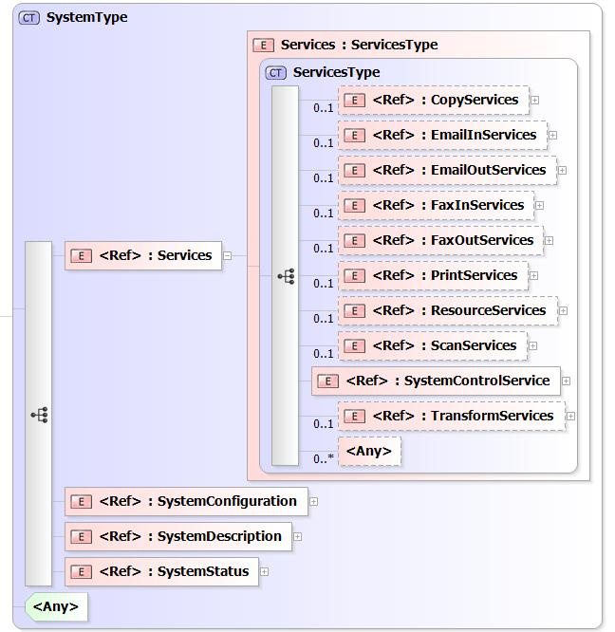
Figure 3 – PWG SM System Object

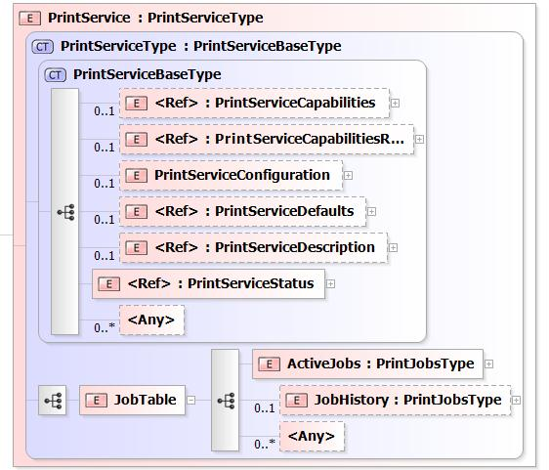
Figure 4 – PWG SM PrintService Object

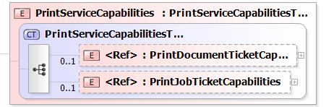
Figure 5 – PWG SM PrintServiceCapabilities Group

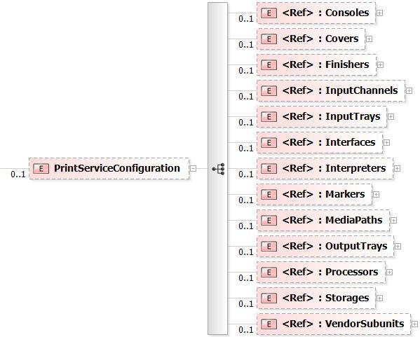
Figure 6 – PWG SM PrintServiceConfiguration Group (subunits)

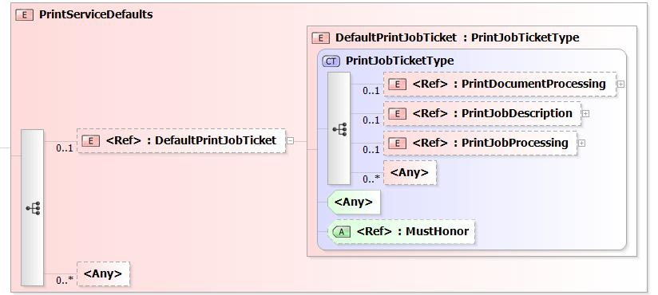
Figure 7 – PWG SM PrintServiceDefaults Group

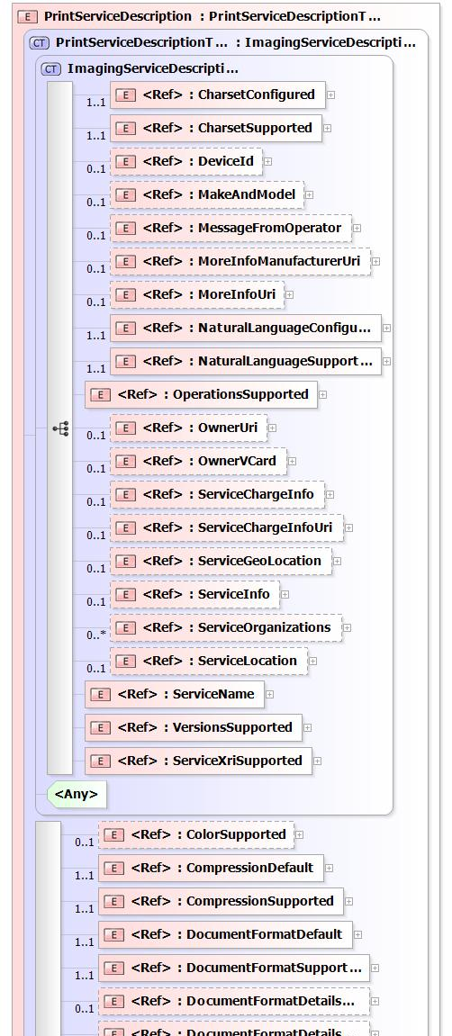
Figure 8 – PWG SM PrintServiceDescription Group (excerpt)

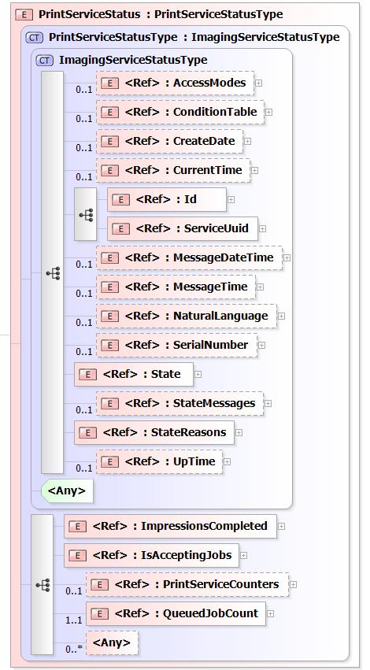
Figure 9 – PWG SM PrintServiceStatus Group

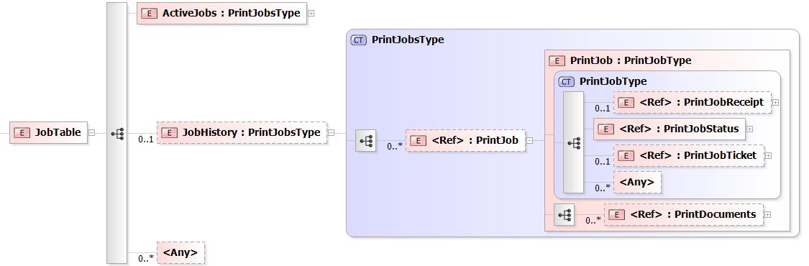
Figure 10 – PWG SM Print JobTable Group (w/ history)
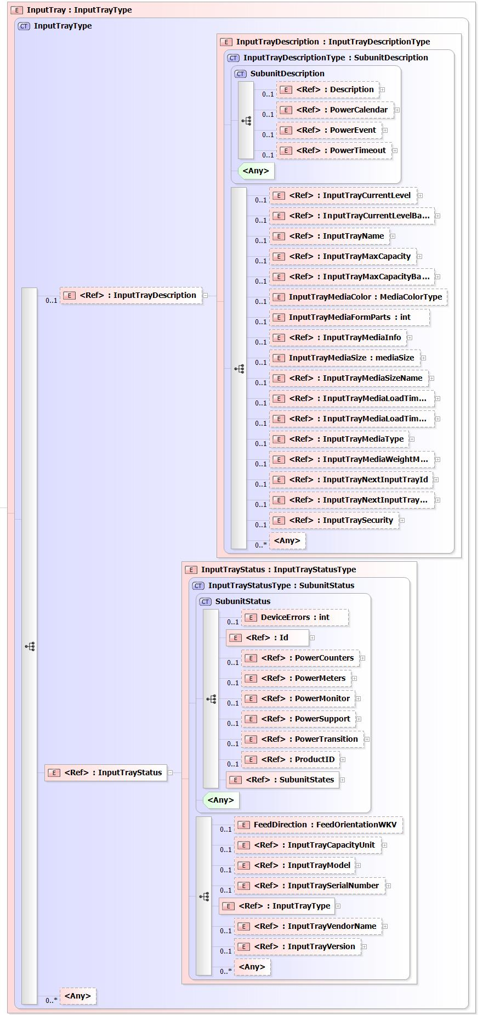
Figure 11 – PWG SM InputTray Object
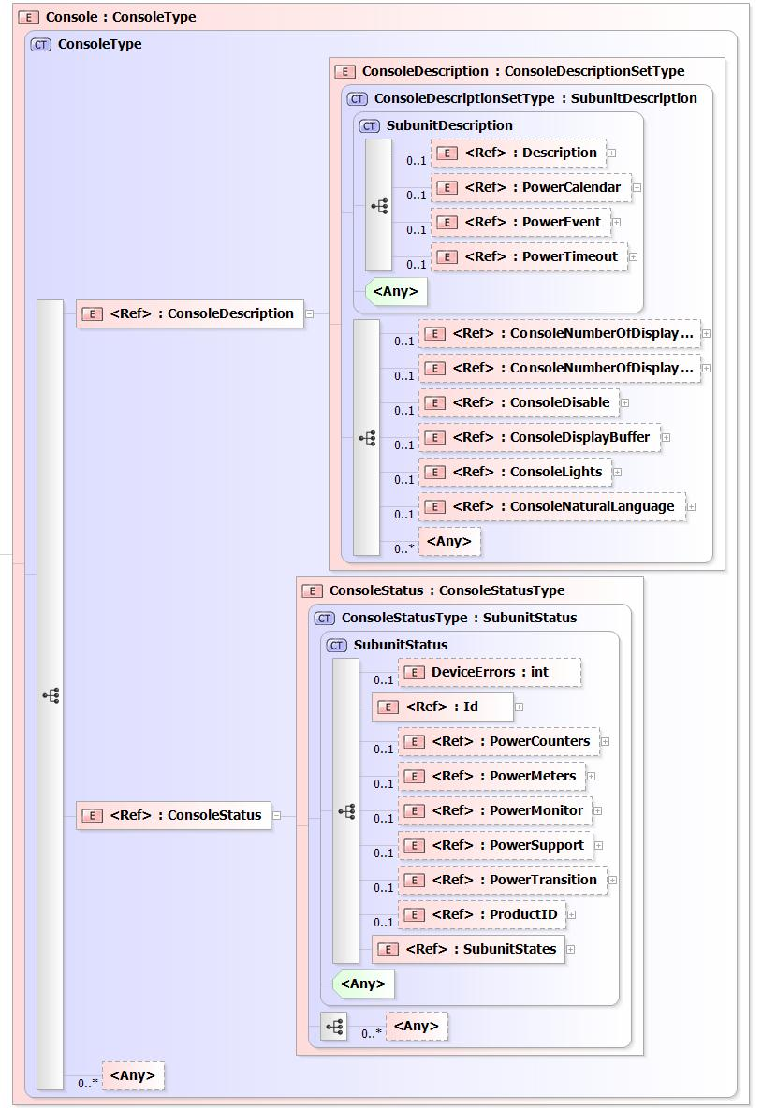
Figure 12 – PWG SM Console Object
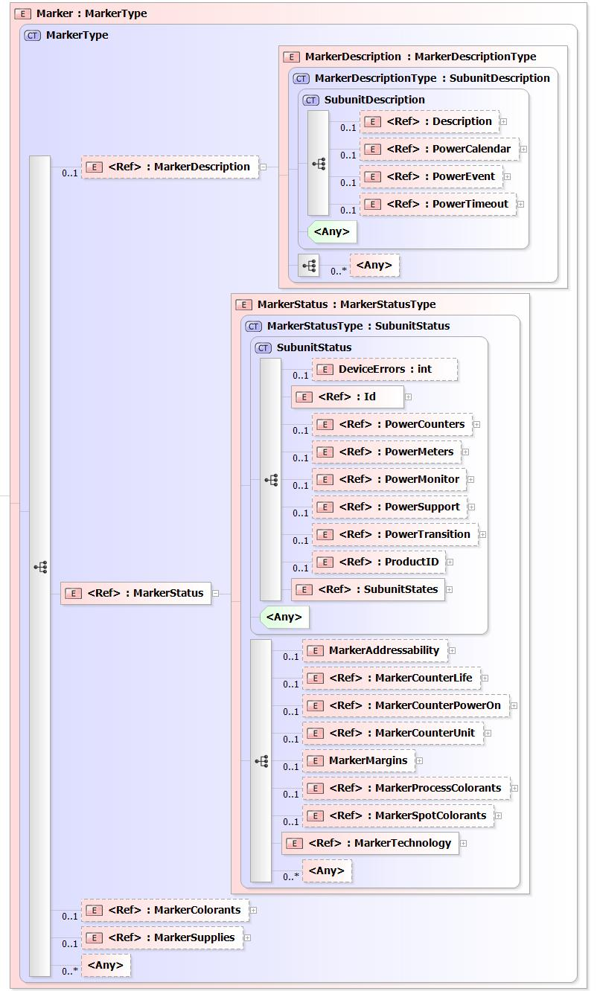
Figure 13 – PWG SM Marker Object
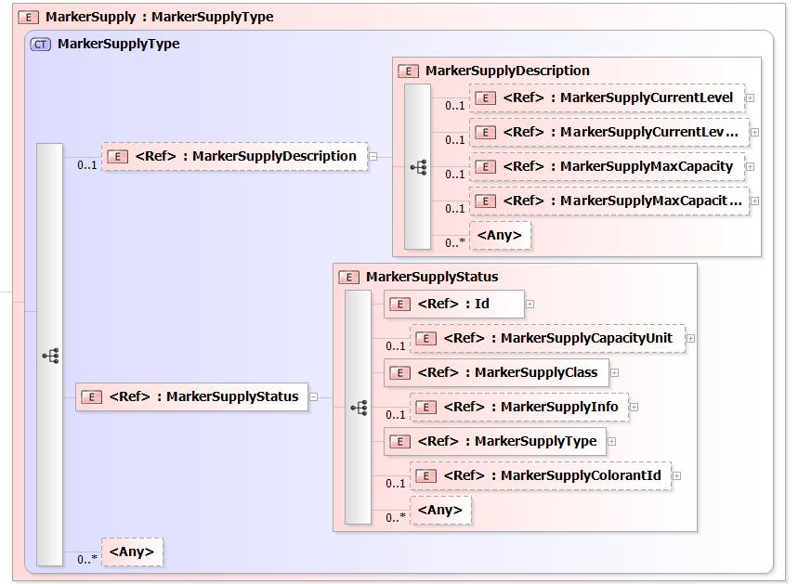
Figure 14 – PWG SM MarkerSupply Object
  - CWMP PrintService Data Model
The following XML docment instance fragment of a CWMP PrintService Data Model illustrates the proposed approach and some of the difficulties in transforming the existing PWG Semantic Model XML document schema into a BBF data model [TR-106].

<?xml version="1.0" encoding="UTF-8"?>
<!-- TR-999 PrintService:1.0 Service Object definition -->
<dm:document xmlns:dm="urn:broadband-forum-org:cwmp:datamodel-1-1"
xmlns:xsi="http://www.w3.org/2001/XMLSchema-instance"
xsi:schemaLocation="urn:broadband-forum-org:cwmp:datamodel-1-1 cwmp-datamodel-1-1.xsd"
spec="urn:broadband-forum-org:tr-999-1-0-0">
<import file="tr-069-biblio.xml" spec="urn:broadband-forum-org:tr-069-biblio"/>
<import file="tr-106-1-0-types.xml" spec="urn:broadband-forum-org:tr-106-1-0">
<dataType name="IPAddress"/>
</import>
<bibliography>
<!—- Set of references here -->
<reference id="TR-135">
<name>TR-135</name>
<title>Data Model for a TR-069 Enabled STB</title>
<organization>BBF</organization>
<category>TR</category>
</reference>
</bibliography>

<!-- CWMP PrintService model with counter of PrintService instances -->
<model name="PrintService:1.0" isService="true">
<parameter name="PrintServiceNumberOfEntries" access="readOnly">
<description>Number of entries in the {{PrintService}} table.
</description>
<syntax>
<unsignedInt/>
</syntax>
</parameter>

<!-- CWMP PrintService object with enable/disable -->
<object name="PrintService.{i}."
access="readOnly" minEntries="0" maxEntries="unbounded"
numEntriesParameter="PrintServiceNumberOfEntries">
<description>PWG PrintService in Services in the CPE.</description>
<parameter name="Enable" access="readWrite">
<description>Enables or disables this {{object}} instance.</description>
<syntax>
<boolean/>
</syntax>
</parameter>
</object>

<object name="PrintService.{i}.Subunits."
access="readOnly" minEntries="1" maxEntries="1">
<description>PWG PrintServiceConfiguration in the CPE.</description>
<parameter name="InputTrayNumberOfEntries" access="readOnly">
<description>Number of entries in the {{InputTray}} table.</description>
<syntax>
<unsignedInt/>
</syntax>
</parameter>
<parameter name="MarkerNumberOfEntries" access="readOnly">
<description>Number of entries in the {{Marker}} table.</description>
<syntax>
<unsignedInt/>
</syntax>
</parameter>
<parameter name="ProcessorNumberOfEntries" access="readOnly">
<description>Number of entries in the {{Processor}} table.</description>
<syntax>
<unsignedInt/>
</syntax>
</parameter>
<!-- more number of entries parameters for all subunit tables -->
</object>

<object name="PrintService.{i}.Subunits.InputTray.{i}."
access="readOnly" minEntries="1" maxEntries="unbounded"
numEntriesParameter="InputTrayNumberOfEntries">
<description>PWG InputTray in the CPE.</description>
<parameter name="Enable" access="readWrite">
<description>Enables or disables this {{object}} instance.</description>
<syntax>
<boolean/>
</syntax>
</parameter>

<!-- PWG InputTrayDescription parameters -->
<parameter name="Description" access="readWrite">
<syntax>
<string/>
</syntax>
</parameter>

<!-- PWG InputTrayStatus parameters -->
<parameter name="DeviceErrors" access="readOnly">
<syntax>
<int/>
</syntax>
</parameter>
<parameter name="Id" access="readOnly">
<syntax>
<int/>
</syntax>
</parameter>
<!-- more parameter definitions that correspond to PWG SM schema elements -->
</object>

<object name="PrintService.{i}.Subunits.Marker.{i}."
access="readOnly" minEntries="1" maxEntries="unbounded"
numEntriesParameter=”MarkerNumberOfEntries”>
<description>PWG Marker in the CPE.</description>
<parameter name="Enable" access="readWrite">
<description>Enables or disables this {{object}} instance.</description>
<syntax>
<boolean/>
</syntax>
</parameter>
<parameter name="ColorantNumberOfEntries" access="readOnly">
<description>Number of entries in the {{Colorant}} table.</description>
<syntax>
<unsignedInt/>
</syntax>
</parameter>
<parameter name="SupplyNumberOfEntries" access="readOnly">
<description>Number of entries in the {{Supply}} table.</description>
<syntax>
<unsignedInt/>
</syntax>
</parameter>

<!-- PWG MarkerDescription parameters -->
<parameter name="Description" access="readWrite">
<syntax>
<string/>
</syntax>
</parameter>

<!-- PWG MarkerStatus parameters -->
<parameter name="DeviceErrors" access="readOnly">
<syntax>
<int/>
</syntax>
</parameter>
<parameter name="Id" access="readOnly">
<syntax>
<int/>
</syntax>
</parameter>
</object>

<object name="PrintService.{i}.Subunits.Marker.{i}.Supply.{i}."
access="readOnly" minEntries="1" maxEntries="unbounded"
numEntriesParameter="SupplyNumberOfEntries">
<description>PWG MarkerSupplies in the CPE.</description>
<parameter name="Enable" access="readWrite">
<description>Enables or disables this {{object}} instance.</description>
<syntax>
<boolean/>
</syntax>
</parameter>

<!-- PWG MarkerSupplyDescription parameters -->
<parameter name="Description" access="readWrite">
<syntax>
<string/>
</syntax>
</parameter>

<!-- PWG MarkerSupplyStatus parameters -->
<parameter name="Id" access="readOnly">
<syntax>
<int/>
</syntax>
</parameter>
<!-- more parameter definitions that correspond to PWG SM schema elements -->
</object>

<object name="PrintService.{i}.Subunits.Processor.{i}."
access="readOnly" minEntries="1" maxEntries="unbounded"
numEntriesParameter=”ProcessorNumberOfEntries”>
<description>PWG Processor in the CPE.</description>
<parameter name="Enable" access="readWrite">
<description>Enables or disables this {{object}} instance.</description>
<syntax>
<boolean/>
</syntax>
</parameter>
<parameter name="PowerCalendarNumberOfEntries" access="readOnly">
<description>Number of entries in the {{PowerCalendar}} table.</description>
<syntax>
<unsignedInt/>
</syntax>
</parameter>
<parameter name="PowerEventNumberOfEntries" access="readOnly">
<description>Number of entries in the {{PowerEvent}} table.</description>
<syntax>
<unsignedInt/>
</syntax>
</parameter>
<parameter name="PowerTimeoutNumberOfEntries" access="readOnly">
<description>Number of entries in the {{PowerTimeout}} table.</description>
<syntax>
<unsignedInt/>
</syntax>
</parameter>
</object>

<object name="PrintService.{i}.Subunits.Processor.{i}.PowerCalendar.{i}."
access="readOnly" minEntries="1" maxEntries="unbounded"
numEntriesParameter="PowerCalendarNumberOfEntries">
<description>PWG ProcessorDescription.PowerCalendar in the CPE.</description>
<parameter name="Id" access="readOnly">
<syntax>
<int/>
</syntax>
</parameter>
<parameter name="RequestPowerState" access="readWrite">
<syntax>
<string/>
</syntax>
</parameter>
<parameter name="CalendarRunOnce" access="readWrite">
<syntax>
<boolean/>
</syntax>
</parameter>
</object>

<object name="PrintService.{i}.Capabilities."
access="readOnly" minEntries="1" maxEntries="1">
<description>PWG PrintServiceCapabilities in the CPE.</description>
<parameter name="Enable" access="readWrite">
<description>Enables or disables this {{object}} instance.</description>
<syntax>
<boolean/>
</syntax>
</parameter>
</object>

<object name="PrintService.{i}.Capabilities.JobDescription."
access="readOnly" minEntries="1" maxEntries="1">
<description>PWG PrintJobDescriptionCapabilities in the CPE.</description>
<parameter name="ElementsNaturalLanguage" access="readWrite">
<syntax>
<string/>
</syntax>
</parameter>
<!-- more parameter definitions that correspond to PWG SM schema elements -->
</object>

<object name="PrintService.{i}.Capabilities.JobProcessing."
access="readOnly" minEntries="1" maxEntries="1">
<description>PWG PrintJobProcessingCapabilities in the CPE.</description>
<parameter name="JobDelayOutputUntil" access="readWrite">
<syntax>
<string/>
</syntax>
</parameter>
<!-- more parameter definitions that correspond to PWG SM schema elements -->
</object>

<object name="PrintService.{i}.Capabilities.DocumentDescription."
access="readOnly" minEntries="1" maxEntries="1">
<description>PWG PrintDocumentDescriptionCapabilities in the CPE.</description>
<parameter name="DocumentDigitalSignature" access="readWrite">
<syntax>
<string/>
</syntax>
</parameter>
<!-- more parameter definitions that correspond to PWG SM schema elements -->
</object>

<object name="PrintService.{i}.Capabilities.DocumentProcessing." access="readOnly"
minEntries="1" maxEntries="1">
<description>PWG PrintDocumentProcessingCapabilities in the CPE.</description>
<parameter name="NumberUp" access="readWrite">
<description>Comma-separated list of allowed integer values</description>
<syntax>
<list/>
<int/>
</syntax>
</parameter>
<!-- more parameter definitions that correspond to PWG SM schema elements -->
</object>

<!-- skip PWG PrintServiceCapabilitiesReady – not interesting over broadband -->

<object name="PrintService.{i}.Defaults."
access="readOnly" minEntries="1" maxEntries="1">
<description>PWG PrintServiceDefaults in the CPE.</description>
<parameter name="Enable" access="readWrite">
<description>Enables or disables this {{object}} instance.</description>
<syntax>
<boolean/>
</syntax>
</parameter>
</object>

<object name="PrintService.{i}.Defaults.JobDescription."
access="readOnly" minEntries="1" maxEntries="1">
<description>PWG PrintJobDescription in the CPE.</description>
<parameter name="ElementsNaturalLanguage" access="readWrite">
<syntax>
<string/>
</syntax>
</parameter>
<!-- more parameter definitions that correspond to PWG SM schema elements -->
</object>

<object name="PrintService.{i}.Description."
access="readOnly" minEntries="1" maxEntries="1">
<description>PWG PrintServiceDescription in the CPE.</description>
<parameter name="CharsetConfigured" access="readWrite">
<syntax>
<string/>
</syntax>
</parameter>
<!-- more parameter definitions for all PrintService description -->
</object>

<object name="PrintService.{i}.Status."
access="readOnly" minEntries="1" maxEntries="1">
<description>PWG PrintServiceStatus in the CPE.</description>
<parameter name="AccessModes" access="readOnly">
<description>Comma-separated list of access mode keywords</description>
<syntax>
<list/>
<string/>
</syntax>
</parameter>
<parameter name="ConditionNumberOfEntries" access="readOnly">
<description>Number of entries in the {{Condition}} table.</description>
<syntax>
<unsignedInt/>
</syntax>
</parameter>
<parameter name="CreateDate" access="readOnly">
<syntax>
<string/>
</syntax>
</parameter>
<!-- more parameter definitions for PrintService status -->
</object>

<!-- profile statements – i.e., imported profiles start here -->
</model>
</dm:document>

- Proxy Implementation Guidance
  - PWG PrintService to IPP Proxy Guidance
Table 1 – PWG PrintService to IPP Proxy Mapping
PWG PrintService Group/Element | IPP Printer/Job Attribute | IETF/PWG  Reference
PrintServiceCapabilities→ | Printer→ | RFC 2911
PrintDocumentTicketCapabilities→
PrintDocumentDescriptionCapabilities→
(ImagingDocumentDescriptionCapabilities)
DocumentDigitalSignature | document-digital-signature-supported | PWG5100.7
DocumentMessage | (none – ‘true’ for PWG5100.7) | PWG5100.7
DocumentName | (none – ‘true’ for PWG5100.7) | PWG5100.7
DocumentNaturalLanguage | document-natural-language-supported | PWG5100.7
(PrintService specific elements)
CompressionSupplied | compression-supported | RFC 2911
DocumentCharsetSupplied | document-charset-supported | PWG5100.7
DocumentDigitalSignatureSupplied | document-digital-signature-supported | PWG5100.7
DocumentFormatDetailsSupplied | document-format-details-supported | PWG5100.7
DocumentFormatSupplied | document-format-supported | RFC 2911
DocumentFormatVersionSupplied | document-format-version-supported | PWG5100.7
DocumentMessageSupplied | (none – ‘true’ for PWG5100.7) | PWG5100.7
DocumentMetadata | (none – ‘true’ for JPS3) | JPS3
DocumentNameSupplied | (none – ‘true’ for PWG5100.7) | PWG5100.7
DocumentUri | (none – ‘true’ for PWG5100.5) | PWG5100.5
Impressions | (none – ‘true’ for PWG5100.5) | PWG5100.5
KOctets | (none – ‘true’ for PWG5100.5) | PWG5100.5
MediaSheets | (none – ‘true’ for PWG5100.5) | PWG5100.5
PageOrderReceived | (none – ‘true’ for PWG5100.5) | PWG5100.5
PrintDocumentProcessingCapabilities→
(ImagingDocumentProcessingCapabilities)
NumberUp | number-up-supported | RFC 2911
PresentationDirectionNumberUp | presentation-direction-number-up | PWG5100.3
(PrintService specific elements)
Copies | copies-supported | RFC 2911
CoverBack | job-cover-back-supported | PWG5100.5
CoverFront | job-cover-front-supported | PWG5100.5
DocumentPassword | document-password-supported | JPS3
FeedOrientation | feed-orientation-supported | PWG5100.11
Finishings | finishings-supported | RFC 2911
FinishingsCol | finishings-col-supported | PWG5100.3
FontNameRequested | font-name-requested-supported | PWG5100.11
FontSizeRequested | font-size-requested-supported | PWG5100.11
ForceFrontSize | force-front-side-supported | PWG5100.3
ImpositionTemplate | imposition-template-supported | PWG5100.3
InsertSheets | insert-sheet-supported | PWG5100.3
Media | media-supported | RFC 2911
MediaType | media-type-supported | PWG5100.3
MediaColDatabase | (none – not in CWMP model) | PWG5100.11
MediaColSupported | media-col-supported | PWG5100.3
MediaInputTrayCheck | media-input-tray-check-supported | PWG5100.3
OrientationRequested | orientation-requested-supported | RFC 2911
OutputBin | output-bin-supported | PWG5100.2
OutputDevice | output-device-supported | PWG5100.7
PageDelivery | page-delivery-supported | PWG5100.3
PageRanges | page-ranges-supported | RFC 2911
PagesPerSubset | pages-per-subset-supported | JPS3
PrintColorMode | print-color-mode-supported | JPS3
PrintContentOptimize | print-content-optimize-supported | PWG5100.7
PrintRenderingIntent | print-rendering-intent-supported | JPS3
Quality | print-quality-supported | RFC 2911
Resolution | printer-resolution-supported | RFC 2911
SeparatorSheets | separator-sheets-supported | PWG5100.3
SheetCollate | sheet-collate-supported | RFC 3381
Sides | sides-supported | RFC 2911
XImagePosition | x-image-position-supported | PWG5100.3
XImageShift | x-image-shift-supported | PWG5100.3
XSide1ImageShift | x-side1-image-shift-supported | PWG5100.3
XSide2ImageShift | x-side2-image-shift-supported | PWG5100.3
YImagePosition | y-image-position-supported | PWG5100.3
YImageShift | y-image-shift-supported | PWG5100.3
YSide1ImageShift | y-side1-image-shift-supported | PWG5100.3
YSide2ImageShift | y-side2-image-shift-supported | PWG5100.3

  - PWG PrintService to SNMP Proxy Guidance
- Conformance Requirements
Provide a list of conformance requirements for the standard.
- Internationalization Considerations
For interoperability and basic support for multiple languages, conforming implementations MUST support the UTF-8 [RFC3629] encoding of Unicode [UNICODE] [ISO10646].
- Security Considerations
Provide security considerations for this specification.
- IANA Considerations
Provide IANA registration information for this specification.
Subsections include IANA registration templates using the Example style:
Some IANA registration text.
- References
  - Normative References
[PWG5108.01] W. Wagner and P. Zehler, "MFD Model and Common Semantics, PWG 5108.01, May 2011,
ftp://ftp.pwg.org/pub/pwg/candidates/cs-sm20-mfdmodel10-20110415-5108.01.pdf
[RFC2707] R. Bergman, T. Hastings, S. Isaacson, H. Lewis, "Job Monitoring MIB v1.0", IETF RFC 2707, November 1999,
ftp://ftp.ietf.org/rfc/rfc2707.txt
[RFC2911] T. Hastings, R. Herriot, R. deBry, S. Isaacson, P. Powell, "Internet Printing Protocol/1.1: Model and Semantics", IETF RFC 2911, September 2000,
ftp://ftp.ietf.org/rfc/rfc2911.txt
[RFC3805] R. Bergman, H. Lewis, I. McDonald, "Printer MIB v2", IETF RFC 3805, June 2004,
ftp://ftp.ietf.org/rfc/rfc3805.txt
[RFC3806] R. Bergman, H. Lewis, I. McDonald, "Printer Finishing MIB", IETF RFC 3806, June 2004,
ftp://ftp.ietf.org/rfc/rfc3806.txt
[TR-069] Broadband Forum, "CPE WAN Management Protocol Amendment 3", BBF Technical Report 069 Release 3.2, November 2010,
http://www.broadband-forum.org/technical/trlist.php
[TR-098] Broadband Forum, "Internet Gateway Device Data Model for TR-069 Amendment 2", BBF Technical Report 098 Release 3.0, September 2008,
http://www.broadband-forum.org/technical/trlist.php
[TR-106] Broadband Forum, "Data Model Template for TR-069-Enabled Devices Amendment 5", BBF Technical Report 106 Release 3.2, November 2010,
http://www.broadband-forum.org/technical/trlist.php
[TR-157] Broadband Forum, "Component Objects for CWMP Amendment 3", BBF Technical Report 157 Release 3.2, November 2010,
http://www.broadband-forum.org/technical/trlist.php
[TR-181] Broadband Forum, "Device Data Model for TR-069 Amendment 2", BBF Technical Report 181 Release 4.0, February 2011,
http://www.broadband-forum.org/technical/trlist.php

  - Informative References
[MR-230] Broadband Forum, "TR-069 Deployment Scenarios", BBF Marketing Report 230, August 2010,
http://www.broadband-forum.org/marketing/marketingdocuments.php
[MR-239] Broadband Forum, "Broadband Forum Value Proposition for Connected Home", BBF Marketing Report 239, April 2011,
http://www.broadband-forum.org/marketing/marketingdocuments.php
[RFC2567] F.D. Wright, "Design Goals for an Internet Printing Protocol", IETF RFC 2567, April 1999,
ftp://ftp.ietf.org/rfc/rfc2567.txt
[RFC2568] S. Zilles, "Rationale for the Structure of the Model and Protocol for the Internet Printing Protocol", IETF RFC 2568, April 1999,
ftp://ftp.ietf.org/rfc/rfc2568.txt
[TR-104] Broadband Forum, "DSLHomeTM Provisioning Parameters for VoIP CPE", BBF Technical Report 131 Release 3.2, November 2009,
http://www.broadband-forum.org/technical/trlist.php
[TR-131] Broadband Forum, "ACS Northbound Interface Requirements", BBF Technical Report 131 Release 3.2, November 2009,
http://www.broadband-forum.org/technical/trlist.php
[TR-135] Broadband Forum, "Data Model for a TR-069 Enabled STB Amendment 1", BBF Technical Report 135 Release 3.0, November 2010,
http://www.broadband-forum.org/technical/trlist.php
[TR-140] Broadband Forum, "TR-069 Data Model for Storage Service Enabled Devices Amendment 1", BBF Technical Report 140 Release 3.0, April 2010,
http://www.broadband-forum.org/technical/trlist.php
[TR-143] Broadband Forum, "Enabling Network Throughput Performance Tests and Statistical Monitoring", BBF Technical Report 143 Release 3.0, May 2008,
http://www.broadband-forum.org/technical/trlist.php
[TR-196] Broadband Forum, "Femto Access Point Service Data Model Amendment 1", BBF Technical Report 196, May 2011,
http://www.broadband-forum.org/technical/trlist.php

- Editors' Addresses
Nancy Chen
Oki Data Solutions and Technology Phone: 856-222-7006
2000 Bishops Gate Blvd
Mt Laurel, NJ 08003 Email: nchen@okidata.com
Ira McDonald
High North Phone: 906-494-2434
PO Box 221
Grand Marais, MI 49839 Email: blueroofmusic@gmail.com
The editors would also like to thank the following individuals for their contributions to this document:
Laxman J Bhat – Celstream
Nagaraj Ghatigar – Celstream
Subramanyan Krishnan – Celstream
Ranga Raj – Thinxtream Technologies
Anil Thakkar – Thinxtream Technologies

- Change History
  - March 12, 2012
Sixth draft.

- Revised section 4.2 to update PWG SM figures as needed.
- Added new section 5 Proxy Implementation Guidance.
- Added new section 5.1 PWG PrintService to IPP Proxy Guidance.
- Added new Table 1 PWG PrintService to IPP Proxy Mapping, filling in for PrintServiceCapabilities.
  - December 5, 2011
Fifth draft.

- Nancy Chen revised PrintService sketch in section 4.3 to fix XML syntax and editing errors to allow correct display in Altova XML Spy – thanks!
  - December 3, 2011
Fourth draft.

- Revised Abstract, Introduction, etc., to reflect phased approach – PrintService first, then other Scan, Fax, MFD, etc., data models per CWMP BOF discussions.
- Added new section 4.1 Approach to Technical Approach, for clarity.
- Added new section 4.2 PWG Semantic Model Print Service, with current PWG SM figures for System, PrintService, all top groups w/in PrintService, and selected Subunits to clarify the mapping.
- Moved former section 4.1 to section 4.3 CWMP PrintService Data Model per CWMP BOF discussions.
- Revised section 4.3 to remove secondary Device.Config and Device.UserInterface objects – changed to service-centric model of STB (TR-135) and Storage (TR-140).
  - September 26, 2011
Third draft.

- Corrected various typos per Nancy Chen, Ranga Raj, and Laxman J. Bhat.
- Revised section 3.2.4 Print Kiosks managed by Telecom Providers to add introduction to Cloud Print use cases and notion of management/provisioning of the Print Kiosks by Telecom providers per Laxman J. Bhat.
- Revised section 4.1 MFDService Model to use correct Secondary Common Objects of Device.Config and Device.UserInterface per Laxman J. Bhat.

  - September 21, 2011
Second draft.

- Revised section 3.1 Rationale to include content from Nancy Chen.
- Revised section 3.2 Use Cases to include content from Ranga Raj.
- Added section 3.3 Deployment Scenarios to include content from Ranga Raj.
- Revised section 4 MFD Data Model for CWMP to explain machine translation.
- Revised section 4.1 MFDService Model to add realistic excerpts from PWG SM.
  - September 14, 2011
Initial draft.

