Meeting Minutes

PWG MFD Semantic Model Face-to-Face

September 26, 2007

Attendees:

Ron Bergman | Ricoh
Shah Bhatti | Samsung
Nancy Chen | Oki Data
Lee Farrell | Canon
Harry Lewis | InfoPrint
Ira McDonald | Blue Roof Music/High North, Inc.
Glen Petrie | Epson
Jerry Thrasher | Lexmark
Bill Wagner | TIC
David Whitehead | Lexmark
Peter Zehler | Xerox

- Review of wd-mfdscan10-20070918.doc

- We agreed to the following editorial changes:
  - Line 178 - change multifunction device to MultiFunction Device
  - Global change – capitalize the letters in a terminology that are used for mnemonic representation
  - Line 179 - change operation model to functional model
  - Line 181 - emphasize network
  - Global change - replace PC and workstation with computer
  - Global change - User to End User
  - Line 189 - change protects to protect
  - Line 204 - change description to descriptive
  - Line 234 & 242 - prepend with Scan
  - Line 290 - change storage location to Template Repository
  - Global change in Design Requirements sections – Use capitalized letters in MUST, SHOULD, etc
  - Line 370 – do not require sensing of documents placed on scanner (i.e. no hardware requirements)
  - AI - Peter Zehler - supply definition of Template Repository
  - AI – Glen Petrie – Send remaining editorial edits to Nancy Chen

- Page 31 Fig. 17 state transition from Test to Idle is missing, not consistent with Fig. 18.

- Review of wd-mfdscan10-20070921.doc
- Page 34 Fig. 18 detailed state transition diagram is very hard to read.
AI – Peter Zehler – Rework Detailed Service Transition Diagram
- Discussions of the “Create Scan Job Template from a Remote Scan Client” use case.
The discussion focused on its protocol, object attribute, and security ramifications

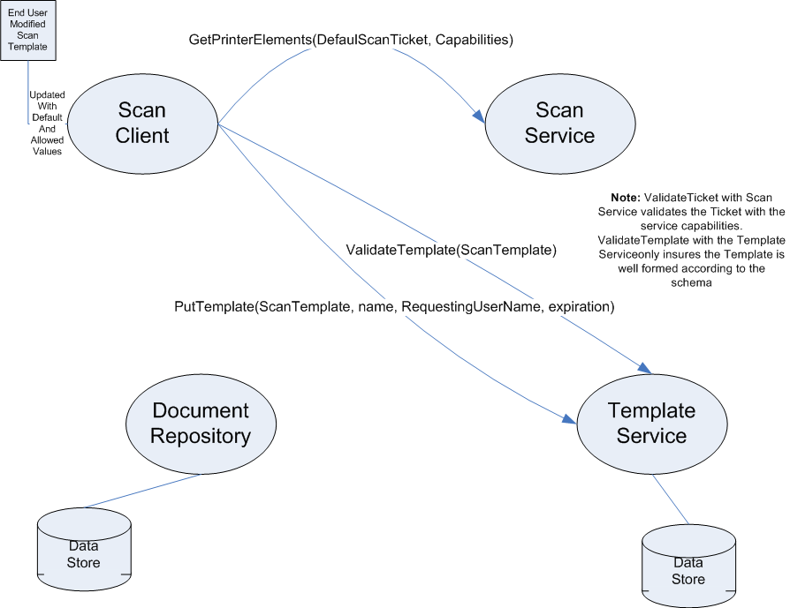

Pete reviewed the Scan Service interfaces, Template Service interfaces, data objects, attributes defined so far. Then Pete drew the diagram above as we walked through the “Create Can Job Template from a Remote Scan Client” use case to verify the semantics and identify further requirements needed.

ISSUE: We need to avoid proxy authentication (e.g. Scan Client passes authentication tokens to Scan Service, Scan Service assumes the role of the Scan Client to store data in the Document Repository.)
RESOLUTION: It is the responsibility of the End User to insure that the Document repository access right be set so that the Scan Service has write access to the scan destination and restricts read access as appropriate. Note that this simplifies the system since each entity uses its own security credentials. The rights management of the document repository is not integrated into the Scan Service protocol. The rights management of the document repository is managed outside this protocol. Note: The scan destination should be a directory and the Scan Service will name the file containing the Scan Document.
ISSUE: How is the Scan Client informed of the location of his Scan Document?
ISSUE: How is the above issue handled for Scan Templates given that templates are simply named vs. Documents that have a URL specifying its location.
RESOLUTION: Templates are associated with the originating user.
ISSUE: Is there a need to specify what Scan Service is allowed to access the Template or repository as a whole?
ISSUE: Is there a need for Restricted Use Scan Template (i.e. restrict the access and use of template stored in the Template Repository to authorized End Users)
POSSIBLE SOLUTION: Addition of elements to Scan Template to flag Scan Template as restricted. Add requirement of Scan Service and Template Service to compare user associated with an operation against user name associated with Scan Template.
ISSUE: Scan Template identification
RESOLUTION: Scan Template must be named, have an originating user name and be typed. The type is already included in the XML namespace. The username and name can be added to the schema or we can overload existing elements.
ISSUE: what elements should be used to hold the name of the template and the originating user?
ISSUE: What security attributes are needed in the Scan Service protocol?
RESOLUTION: We have the RequestingUserName that carries an unauthenticated user name. The semantics from IPP already allows the replacement of the value with a more trusted value if one is available. Implementations are free to use a variety of security framework.

- Discussion points for Friday:
- Validate above resolutions and resolve open issues.
- Do we want signed documents or other security on the document content? (The result of this discussion should also be discussed for its applicability to Scan Template.)
- Unified data type for semantic elements used in Tickets, DefaultScanTicket and Capabilities.
- Walk through some use cases and flesh out operations and data elements.

