Please Join Us!
Benefits of membership:
Early access to the emerging standards.
You get to influence the direction of the standards during development.
Interact with other vendors and software houses.

Who We Are
The Projector and Display Management Working Group (PDM), an international industry group, is developing management standards for these devices. Our members include manufacturers of video projectors and displays, and software companies that build management software for networks of projectors and displays.

PDM is part of PWG, a program of IEEE-ISTO.

Companies Currently Involved
Canon
Coretronic
Dell
Delta
Epson
NEC
Spinoza Technology

New Remote Management Standards
for Projectors and Displays
Being developed by an independent, multi-company,
international working group,
the Projector & Display Management Working Group (PDM)

PDM

Managing Displays
Inventory
Health and status
Power management
Planning spares
Error alerts
Ensuring proper setup
Predictive maintenance
Theft prevention



Goals
- Provide management information about projectors and large-format displays to remote management applications.
- Build open standards that can benefit all.
- Use existing management protocols.
- Cover most common use cases.
- Define SNMP MIB first, then guidelines for embedded web servers.
- Basic health and status information, basic power control and settings functions now. Advanced management functions later.

Target Devices
- Projectors, from conference rooms up to theaters.
- Large format displays, from digital signage up to jumbotrons.
- (Semi-) Permanently installed projectors and displays, not carry-arounds.
- Management of devices, not delivery of data.
- Not management of desktop monitors.
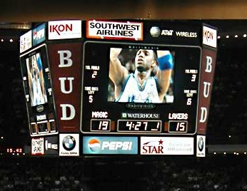

Use Cases (sample)
- What devices do I have in my network?
- What spares do I need to stock?
- Are all devices operating normally?
- Any errors lately?
- What lamps and filters will need to be replaced soon?
- Ensure that all devices are turned off when not in use.
- Correct daily tinkering with setup.
- Ensure that setup is suitable for next user: brightness, contrasts, aspect ratio, mode, input, zoom, etc..
- Alert me when a device is disconnected (theft prevention).

Management Data Items (sample)
- Power state and power controls
- Status of fans, lamps, sensors, covers
- Communications setup and status
- Temperature sensors and switches
- Lamp age, lamp error count, filter age
- Replacement part numbers for FRUs
- Fan speed, fan error count
- Display settings: brightness, contrast, aspect ratio, color temperature, zoom, focus, keystoning,....

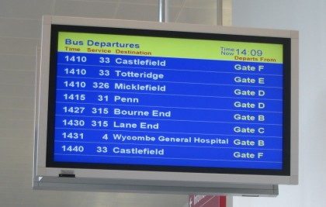

Read Our Docs!
Look at out web sites:
- http://www.pwg.org
- http://pwg-wiki.wikispaces.com/PDM
Read our technical docs
(All docs in ftp://ftp.pwg.org/pub/pwg/pdm/)
FAQs:
.../white/faqs.pdf
Requirements: .../slides/Projector&Display_slides_revised_20060807.ppt
Use cases:
.../wd/ UseCases_v05_20061024.rtf
Status:
.../slides/PWGqtly200702_Proj&DispMgt_status_v01.pdf
Sample property definitions:
.../objects/Interlocks_v12.xml

Printer Working Group?
Why Printers?

The Printer Working Group is an established standards organization with a fifteen year history that includes a number of influential industry standards. Projectors, displays and printers are similar in their manageability in that they share many of the same modeling concepts such as communications, color models, resolution, consumables, and alerts. PWG is a program of IEEE-ISTO, which supports us with administration, process, and intellectual property guidelines.

Contact Information
Email the chairperson for information on our weekly concalls and LiveMeeting broadcasts:
- Richard_Landau@dell.com

